Grade 7 Accelerated · Unit 3 · Thread A · Day 2  Negative Exponents with Variable Bases  Question Bank - Additional 3.T2 ANSWER KEY | Name  Date  Period

Show your work. Circle your final answer.
For questions 1 through 6, write an equivalent expression using only positive exponents. Assume no variable equals 0.
1. 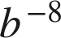
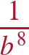

2. 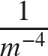


3. 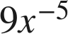
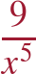

4. 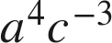
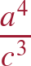

5. 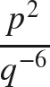
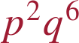

6. 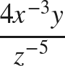
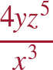

For questions 7 and 8, apply the laws of exponents. Write each answer using only positive exponents.
7. Write an equivalent expression.
a. 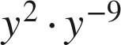
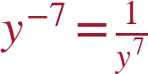
b. 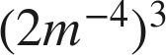
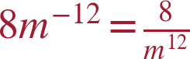
c. 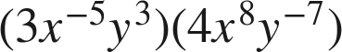
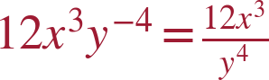

8. Write an equivalent expression.
a. 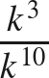
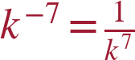
b. 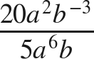
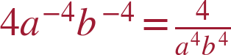
c. 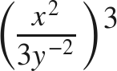
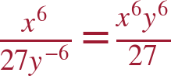

Working backwards.
9. Find the value of that makes each statement true.
a. 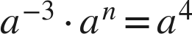
n = 7
b. 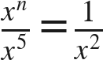
n = 3
n − 5 = −2.
c. 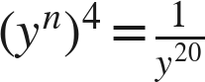
n = −5
4n = −20.

10. Let .
a. Find the value of 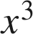 and the value of 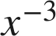.
64 and 1/64
b. Find the value of 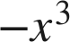. Is it equal to ? Explain.
−64. No — 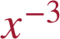 is the reciprocal of 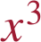, which is 1/64;  is the opposite of .

11. Which expression is equivalent to 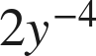 ?
● A. 
○ B. 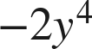
○ C. 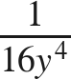
○ D. 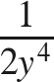
A

12. Select ALL of the expressions that are equivalent to 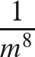.
☒ A. 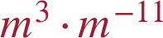
☒ B. 
☒ C. 
☐ D. 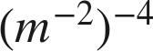
☐ E. 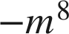
☒ F. 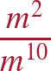
A, B, C and F

